**Ancient Art**

[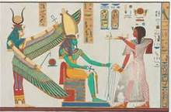](http://www.bing.com/images/search?q=ancient+art&view=detail&id=29C05BE58865FE063CFA365746D40BD7A5F5C23D)

[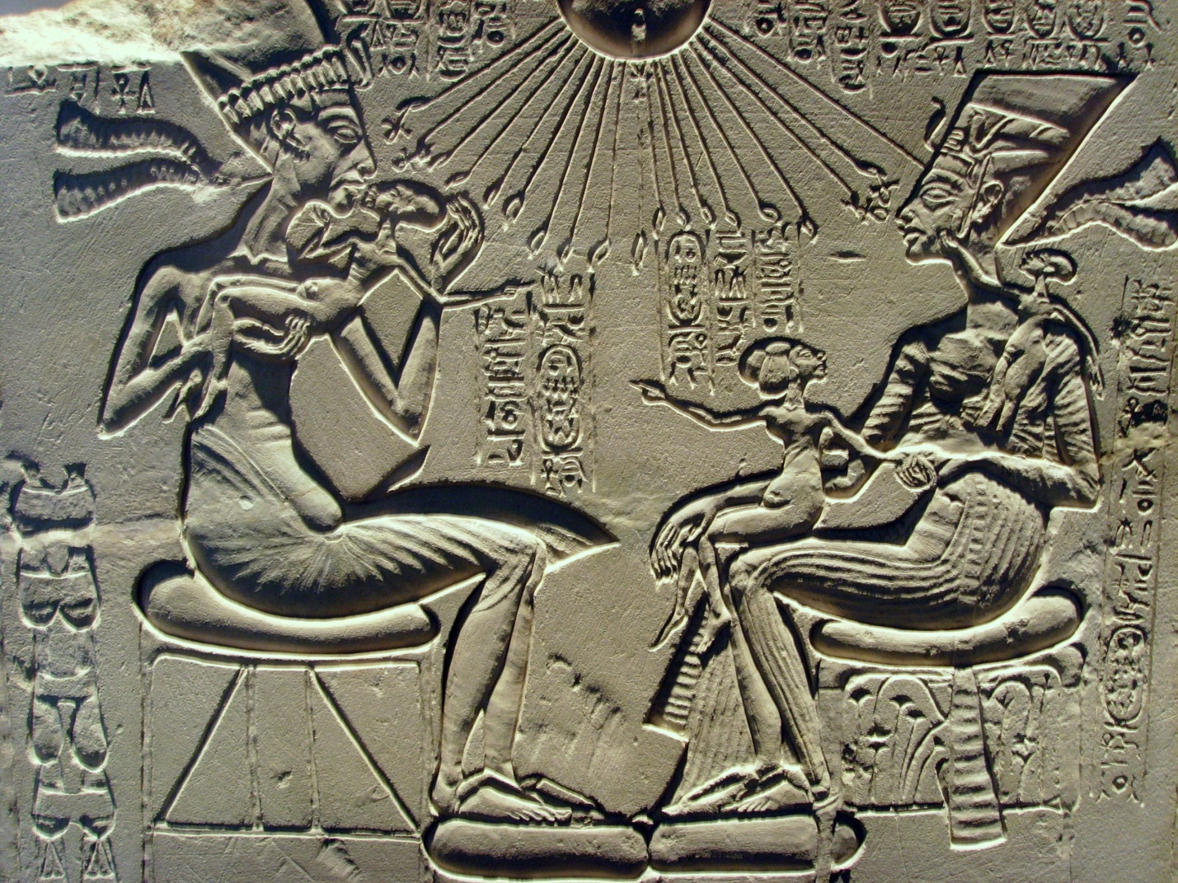](http://clairhart.files.wordpress.com/2011/12/akhenaten_nefertiti_and_their_children.jpg)

[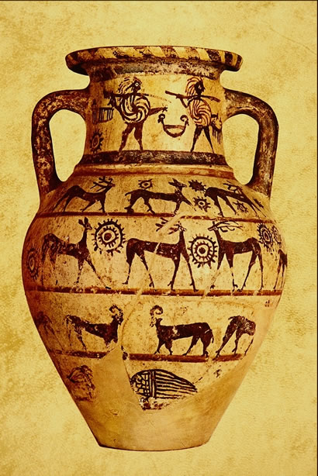](http://historylink101.com/art/AncientArt2/images/503051.jpg)Ancient Art

**The Renaissance**

[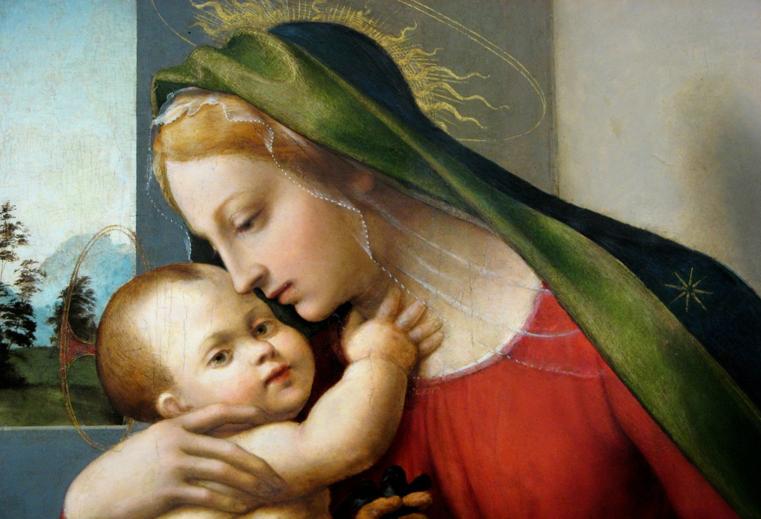](http://images.cdn.fotopedia.com/flickr-2213514852-hd.jpg)

[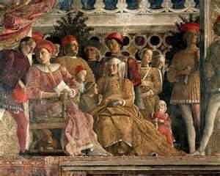](http://www.finearttouch.com/images/Mantegna_mantua_court_.JPG)

[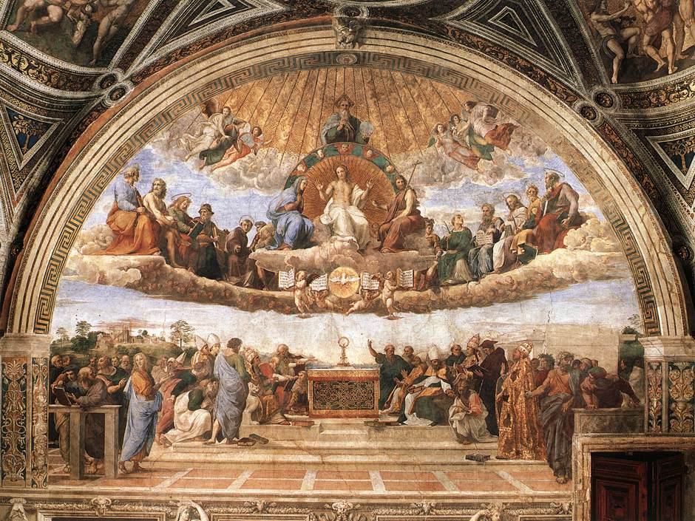](http://www.oneonta.edu/faculty/farberas/arth/Images/ARTH213images/StanzadellaSegnatura/disputa/disputa_large.jpg)Renaissance

**Early American Art**

[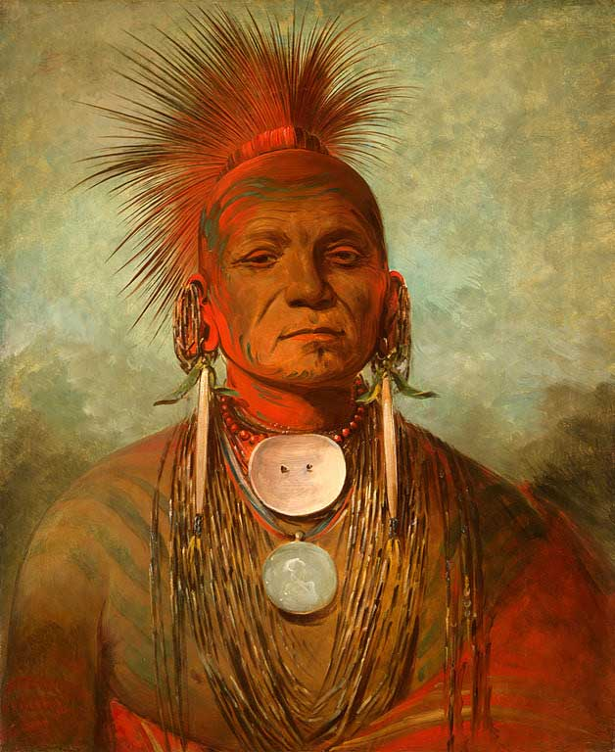](http://www.nga.gov/kids/catlin/See-non-ty-a-big.jpg)

[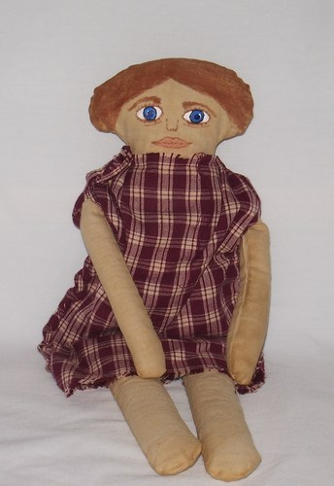](http://www.artfire.com/uploads/product/6/316/82316/3882316/3882316/large/primitive_early_american_handmade_art_doll_cloth_doll_rosabel_gift_0d3e17af.jpg)

[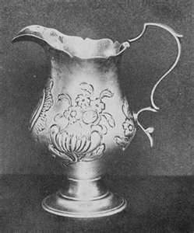](http://www.kellscraft.com/EarlyAmericanCraftsmen/p4113537b.jpg)

**Impressionism (Monet and VanGogh)**

[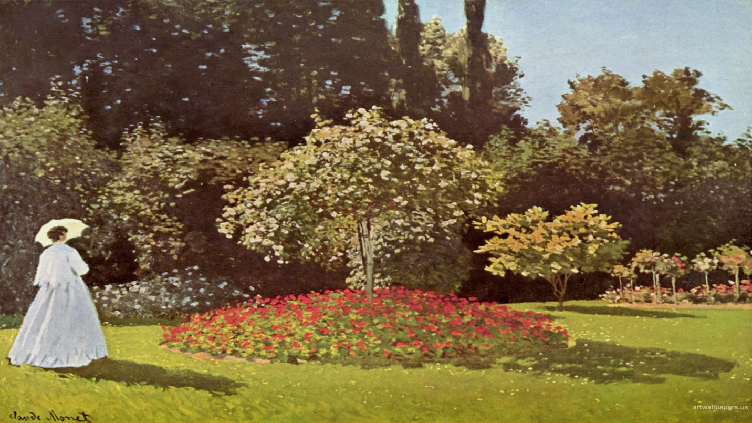](http://www.artwallpapers.us/Claude-Monet/03/Claude-Monet19201080.jpg)

http://www.bing.com/mm/s/loading_lg.gifhttp://www.bing.com/mm/s/loading_lg.gif[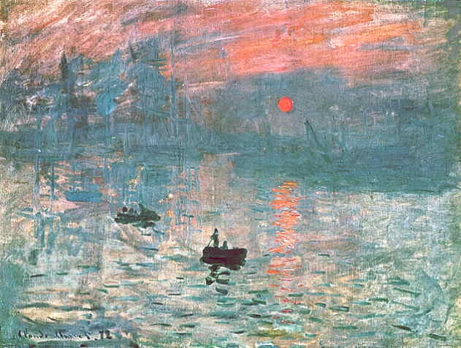](http://www.ibiblio.org/wm/paint/auth/monet/first/impression/impression.jpg)

